# CS 255 System Design Document Template

This template lays out all the different sections that you need to complete for Project Two. Each section has guidance to prompt your thinking. You will need to continually reference the interview transcript as you work to make sure that you are addressing your client’s needs. There is no required length for the final document. Instead the goal is to complete each section based on what your client’s needs are. Remove this note when you are finished, and replace all bracketed text with the relevant information.

## UML Diagrams

### UML Use Case Diagram

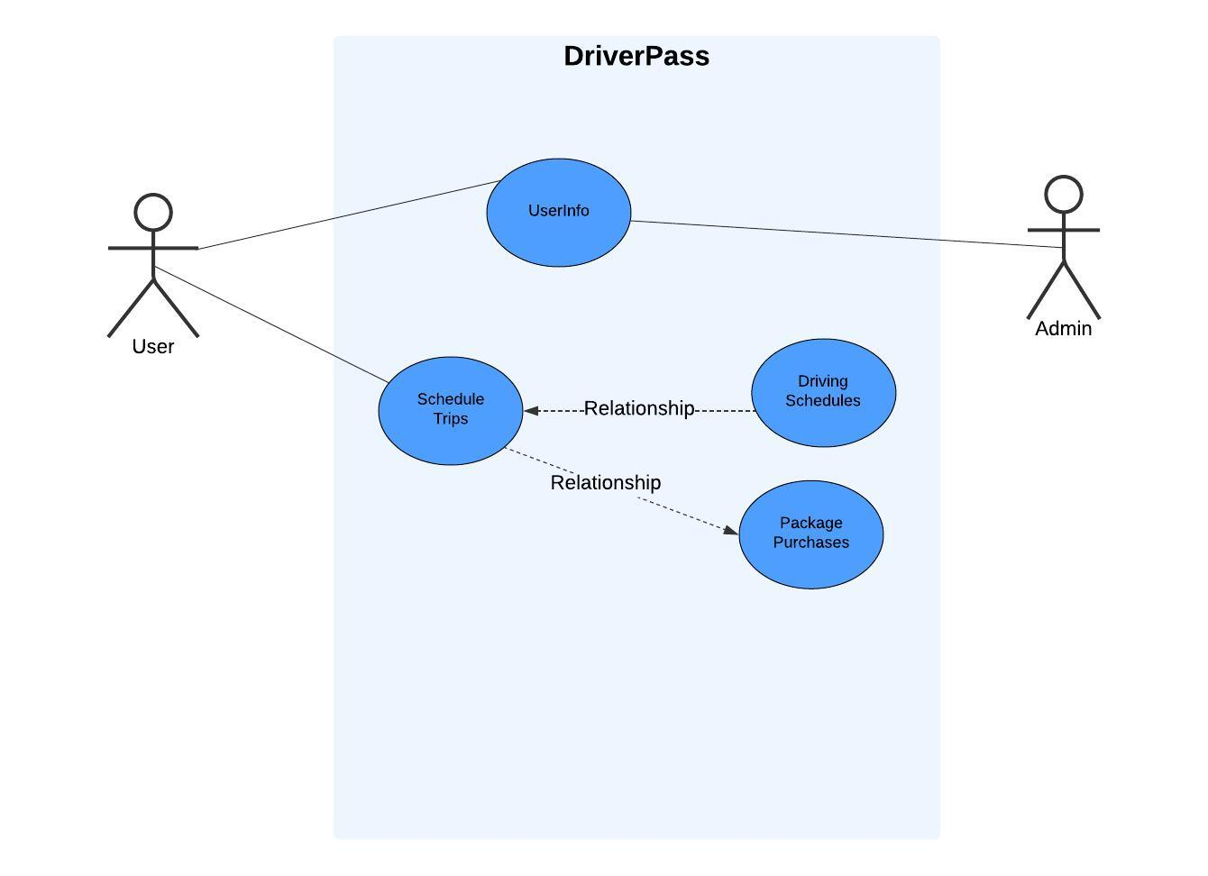

### UML Activity Diagrams

*[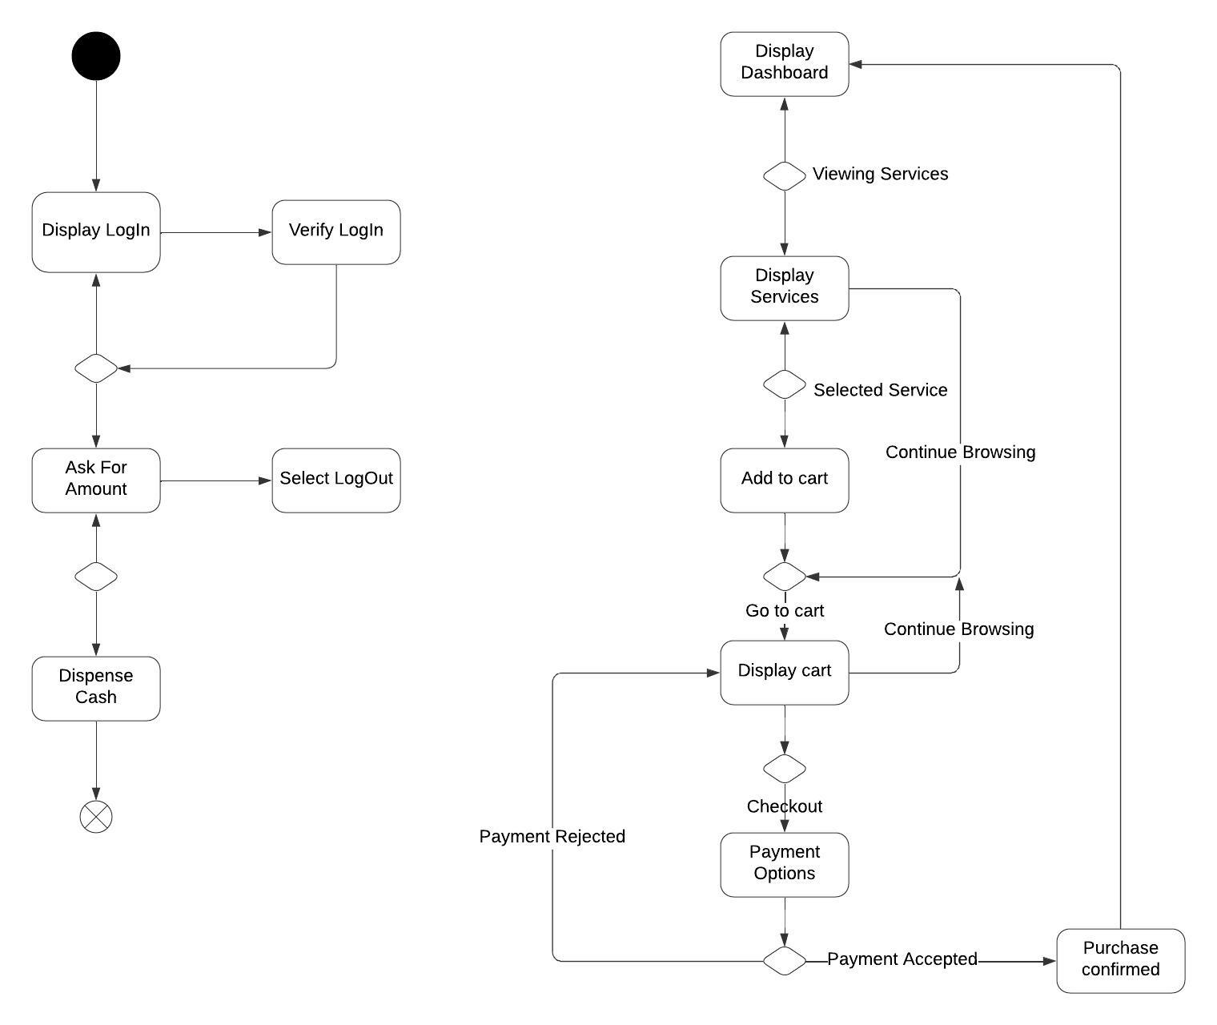*

### UML Sequence Diagram

### UML Class Diagram

## Technical Requirements

*[The DriverPass application requires a third-party hosting service for the web app, allowing users to access it via their web browsers without DriverPass needing to maintain servers. The application must connect to a customer database for storing account information and include an authentication service for user logins. Additionally, it needs to integrate with an external payment service to process customer payments and access the DMV for updates on laws and driver requirements.]*